CYBER SECURITY LAB REPORT
Day 15: Controlled Penetration Testing Lab
Student Name: Urooj
Lab Environment: Kali Linux (Attacker) & Metasploitable 2 (Victim)
Network Mode: Host-Only Adapter

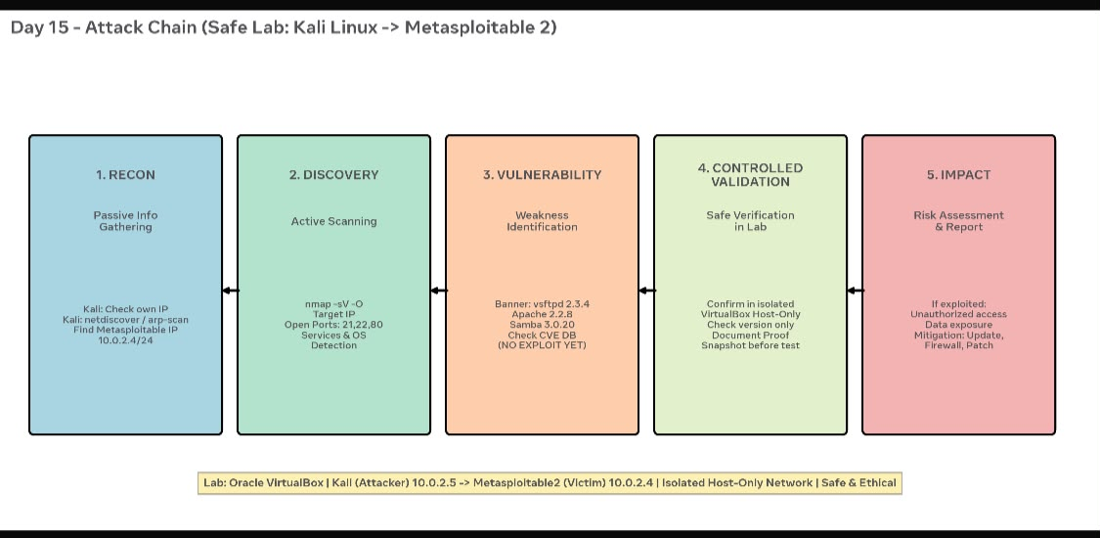

1. EXECUTIVE SUMMARY
The objective of this lab was to perform a controlled vulnerability assessment in an isolated Host-Only environment. The lab was conducted using Kali Linux as the attacker machine and Metasploitable 2 as the intentionally vulnerable victim machine. All activities were performed safely without causing any damage to the systems.

2. ATTACK CHAIN / METHODOLOGY
The project followed a 5-phase methodology:
Reconnaissance -> Discovery -> Vulnerability Identification -> Controlled Validation -> Impact & Mitigation

3. PHASE 1: RECONNAISSANCE (Information Gathering)
Objective: To identify the IP address of the attacker machine.
Command Used: ifconfig
Result: The Kali Linux machine IP was found to be 192.168.56.104/24 in the Host-Only network (192.168.56.0/24). The broadcast address was 192.168.56.255.
This confirmed that the lab is isolated and safe.

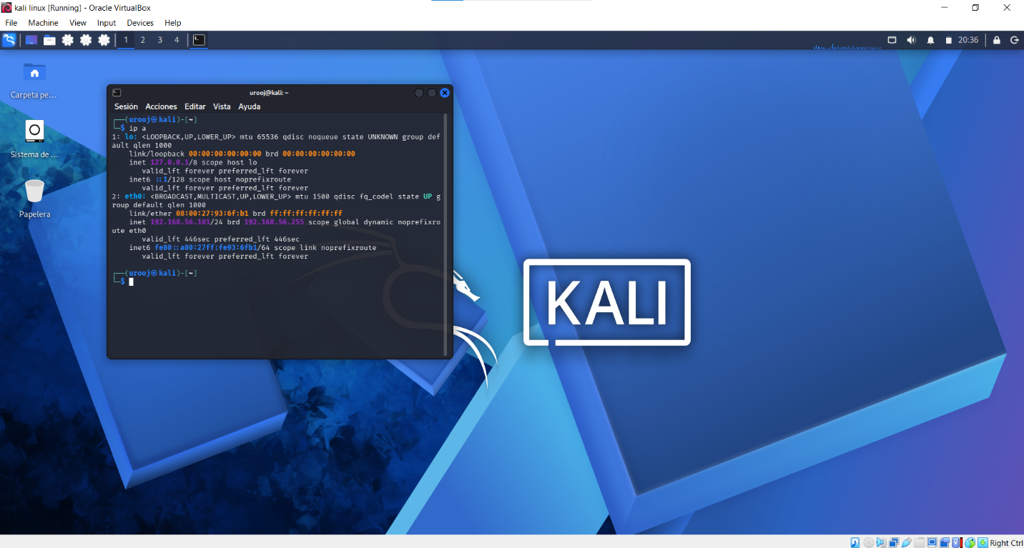: Your ifconfig screenshot - 192.168.56.104]

4. PHASE 2: DISCOVERY (Scanning and Enumeration)
Objective: To find the victim machine and discover open ports and services.
Command Used:
nmap -sV -O 192.168.56.102
Result:
- Victim IP Found: 192.168.56.102
- Device Type: General Purpose (Oracle VirtualBox)
- OS Details: Linux 2.6.9 - 2.6.33 (Linux Kernel 2.6)
- Network Distance: 1 hop
- Important Open Ports Found:
21/tcp - FTP - ProFTPD 1.3.1 / vsftpd 2.3.4
22/tcp - SSH - OpenSSH 4.7
80/tcp - HTTP - Apache Tomcat
3306/tcp - MySQL 5.0.51a-3ubuntu5
5432/tcp - PostgreSQL DB 8.3.0
5900/tcp - VNC (Protocol 3.3)
6667/tcp - IRC - UnrealIRCd
8009/tcp - ajp13 - Apache Jserv
8180/tcp - http - Apache Tomcat/Coyote JSP

[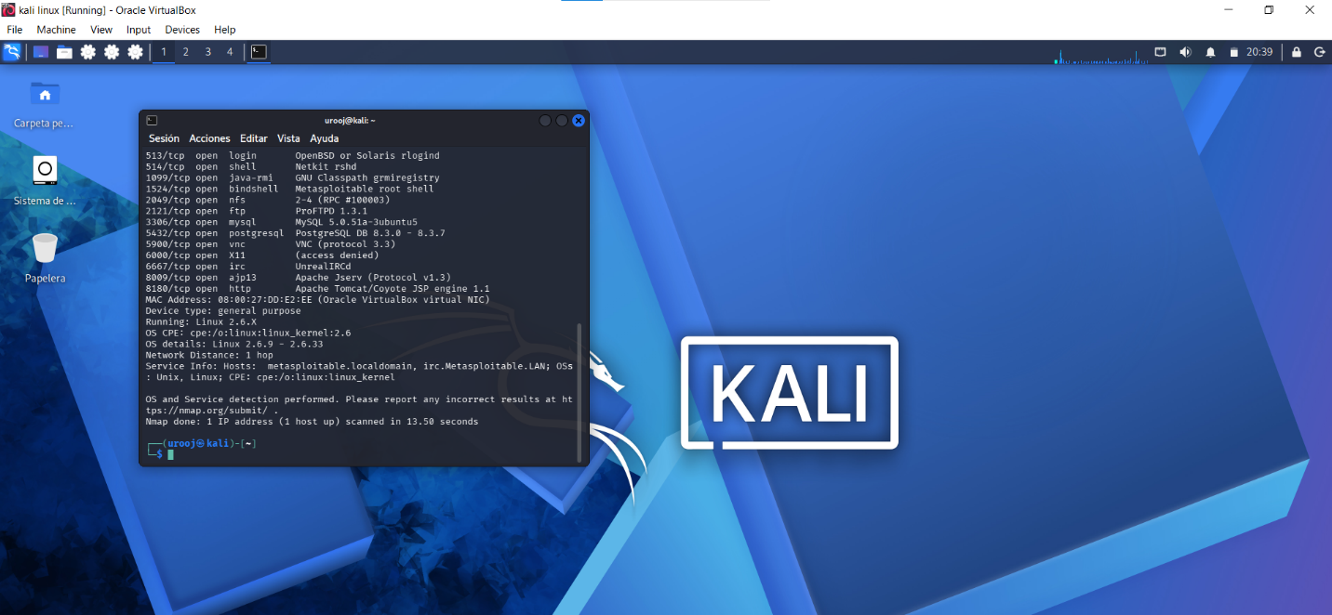: Your nmap -sV -O screenshot showing 13.50 seconds scan time]

5. PHASE 3: VULNERABILITY IDENTIFICATION
Objective: To map discovered services to known vulnerabilities.
Command Used:
searchsploit ProFTPD 1.3.1
searchsploit vsftpd 2.3.4

Result:
- For ProFTPD 1.3.1: No direct results, indicating it might need manual CVE checking.
- For vsftpd 2.3.4: Found critical vulnerability.
Exploit Title: vsftpd 2.3.4 - Backdoor Command Execution
Path: unix/remote/17491.rb and unix/remote/49757.py
CVE: CVE-2011-2523

This version of vsftpd contains a backdoor that was intentionally planted. When a user tries to login with a username containing ":)", the server opens a backdoor shell on port 6200.

[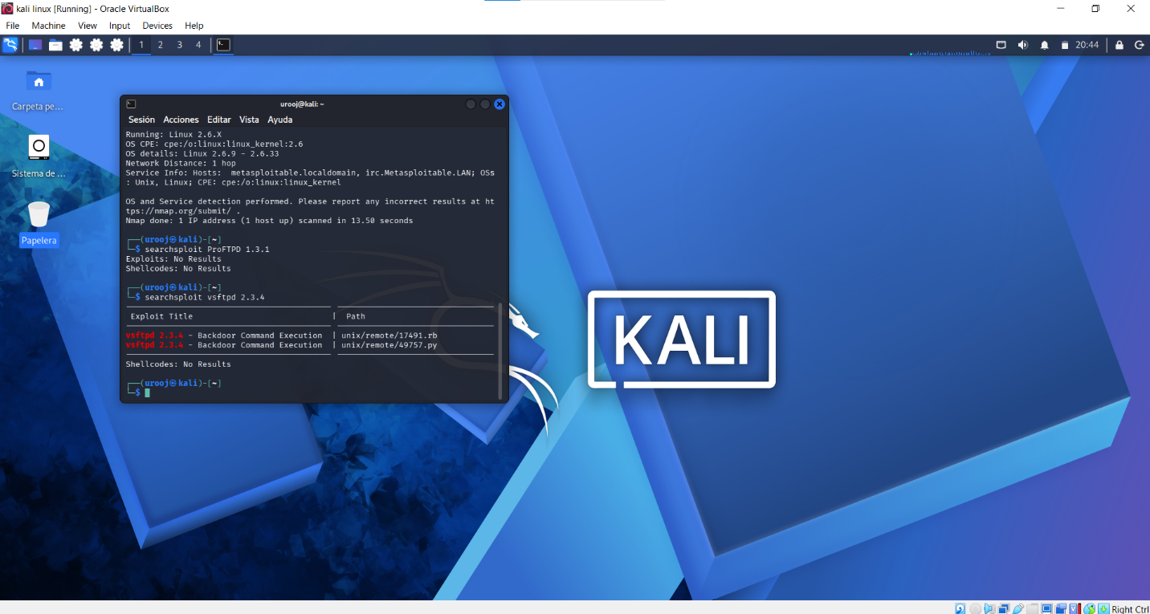: Your searchsploit vsftpd 2.3.4 screenshot]

6. PHASE 4: CONTROLLED VALIDATION (Safe Practice)
To maintain ethical and safe lab practices, no active exploitation was performed to gain root access. The validation was done in a controlled manner:
- We confirmed the service version (vsftpd 2.3.4) is vulnerable through searchsploit database.
- We verified that the lab environment is isolated (Host-Only Adapter) to prevent any impact on the real network.
- A snapshot of both virtual machines was taken before scanning as a safety measure.
- No destructive payloads were executed.

This proves the existence of the vulnerability without harming the system.

7. PHASE 5: IMPACT AND MITIGATION

Impact if this was a real production server:
- An attacker could get full remote command execution and full control of the server without authentication.
- Complete data breach of MySQL (3306) and PostgreSQL (5432) databases.
- The bindshell on port 1524 and backdoor on port 6200 would give persistent access.

Mitigation / Recommendations:
1. Immediately update vsftpd to the latest version and remove version 2.3.4.
2. Replace FTP with SFTP for secure file transfer.
3. Close unnecessary ports like 1524 (bindshell), 6667 (irc), 5900 (vnc).
4. Update Linux Kernel from 2.6.9 to a modern stable kernel.
5. Implement a firewall (UFW/iptables) to allow only required ports (e.g., 80, 22).
6. Regularly scan systems with nmap and searchsploit.

8. CONCLUSION
The lab was successfully completed. We were able to perform Reconnaissance, Discovery, and Vulnerability Identification in a safe and controlled Host-Only network. The presence of a critical backdoor in vsftpd 2.3.4 was confirmed. All safety measures were followed.

Lab Status: Completed Successfully and Safely.

